numbers relative to the indigenous rhizobia (Bohlool and Schmidt 1973; Kapusta and Rouwenhorst 1973; Weaver and Frederick 1974). However, the numbers needed to overcome indigenous rhizobia are in many cases too excessive to be practical.
In much of the soybean-growing area in the north central United States, an area encompassing many soil types, indigeneous strains of Bradyrhizobium japonicum serogroup 123 dominate nodulation of soybeans (Damirgi et al. 1967; Ham et al. 1971b). Although several factors have been examined to account for the success of serogroup 123 (Ham 1980), strain characteristics that confer competitive advantage to 123 remain unknown. The competitive success of 123 was found to be unrelated to an ability to outgrow other indigenous B. japonicum in the host rhizosphere (Moawad et al. 1984). Also, when competition studies were carried out in sterile vermiculite or in soils devoid of naturalized B. japonicum, an isolate of 123 from a midwestern soil was found to be a poor competitor (Kosslak
990
Intra- and inter-specific competition in Rhizobium fredii and Bradyrhizobium japonicum as indigenous and introduced organisms¹

STEPHEN F. DOWDLE² AND B. BEN BOHLOOL³
Department of Microbiology, University of Hawaii, Honolulu, HI, U.S.A. 96822
Received February 25, 1987
Accepted July 3, 1987
DOWDLE, S. F., and BOHLOOL, B. B. 1987. Intra- and inter-specific competition in Rhizobium fredii and Bradyrhizobium japonicum as indigenous and introduced organisms. Can. J. Microbiol. 33: 990-995.

We studied the competition between Bradyrhizobium japonicum and Rhizobium fredii isolates for nodulation of soybean (Glycine max L. Merrill) cultivars Williams and Ai Jiao Zao grown in three different soils in pots. Two of the soils were from People's Republic of China, one from a soybean field in Honghu with no history of Rhizobium inoculation, and one from a rice field in Wuhan with no history of soybean cultivation. The Honghu soil contained B. japonicum and R. fredii (log total number g ⁻¹ = 5.82 ± 0.58); whereas the Wuhan soil only contained B. japonicum (log total number g⁻ ¹ =2.80 ± 0.52). Inoculation did not result in a significant increase in nodule number on plants in either soil. Uninoculated plants of both cultivars harbored only R. fredii in the Honghu soil and only B. japonicum in the Wuhan soil. Even when B. japonicum were inoculated into the Honghu soil, R. fredii occupied the majority of the nodules on both cultivars. In the Wuhan soil, B. japonicum serogroups USDA 110 and USDA 136b (= CB 1809) occupied the majority of the nodules except when an isolate of R. fredii from the soybean soil was added in high numbers. In a Hawaiian soil devoid of B. japonicum or R. fredii, when soybeans were inoculated with isolates of both species, most of the nodules were formed by B. japonicum. The R. fredii isolate could form up to 20% of nodules in this soil, but only on the Ai Jia Zao cultivar. In the Wuhan but not the Hawaiian soil, peat pelleting of seeds with equal numbers of two B. japonicum and one R. fredii isolates increased nodule occupancy by B. japonicum USDA136b serogroup significantly as compared with when the same isolates were inoculated into the soil. The results reported here highlight the critical importance of being indigenous to the competitive success of B. japonicum and R. fredii in nodulation of their soybean host.

DOWDLE, S. F., et BOHLOOL, B. B. 1987. Intra- and inter-specific competition in Rhizobium fredii and Bradyrhizobium japonicum as indigenous and introduced organisms. Can. J. Microbiol. 33: 990-995.
La competition entre les isolats de Bradyrhizobium japonicum et de Rhizobium fredii pour la nodulation du soya (Glycine max (L.) Merrill), a ete etudiee avec les cultivars Williams et Ai Jiao Zao croissant en pots dans trois sols differents. Deux des sols provenaient de la Republique populaire de Chine; Fun d'eux avait ete preleve d'un champ de soya de Honghu qui n'avait pas d'historicite relativement a 1'inoculation de Rhizobium et, 1'autre, avait ete preleve d'un champ de riz de Wuhan qui n'avait pas d'historicite concemant la culture de soya. Le sol de Honghu contenait du B. japonicum et du R. fredii (nombre logarithmique total g^{-I} = 5,82 ± 0,58), alors que le sol de Wuhan ne contenait que du B. japonicum (nombre logarithmique total g⁻ ^{I} = 2,80 ± 0,52). L'inoculation ne s'est pas traduite par une augmentation significative du nombre de nodules dans Fun et 1'autre de ces sols. Les plantes non-inocuaees des deux cultivars n'ont ete porteuses que du R. fredii dans le sol de Honghu et que du B. japonicum dans le sol de Wuhan. Lorsque du sol de Honghu fut inocule avec du B. japonicum, le R. fredii a quand meme occupe la majorite des nodules chez les deux cultivars. Dans le sol de Wuhan, les serogroupes USDA110 et USDA136b (= CB1809) de B. japonicum ont occupe la majorite des nodules, excepte lorsqu'un isolat de R. fredii provenant du champ de soya fut ajoute a forte concentration. Dans un sol hawaien depourvu de B. japonicum et de R. fredii, lorsque les cultivars de soya furent inocules avec les isolats des deux especes, les nodules furent formees en majeure partie pas le B. japonicum. Dans cc sol, 1'isolat de R. fredii a pu former jusqu'a 20% des nodules, mais seulement chez le cultivar Ai Jiao Zao. Dans le sol de Wuhan, mais non dans le sol hawaien, les graines pastillees de tourbe contenant des quantites egales en nombre de deux isolats de B. japonicum et d'un isolat de R. fredii, 1'occupation des nodules a ete augmentee de fagon significative par le serogroupe USDA 136b de B. japonicum, comparativement a 1'inoculation des memes isolats dans les sols. Les resultats presentes ici font ressortir 1'importance critique du caractere indigene pour le succes competitif de B. japonicum et de R. fredii dans la nodulation des soyas-h6tes.
[Traduit par la revue]
Introduction
An important objective in inoculation of legumes with rhizobia is to establish highly effective inoculum strains in the rhizosphere so they can compete successfully for nodule sites against those indigenous in the soil. With respect to soybeans in particular, inoculum strains superior in nitrogen fixation have frequently failed to compete successfully with indigenous rhizobia (Boonkerd et al. 1978; Ham et al. 1971 a; Johnson et al. 1965). Several studies have reported increased recovery of inoculum strains in soybean nodules by applying high cell

Journal Series no. 2992 of the Hawaii Institute for Tropical Agriculture and Human Resources, University of Hawaii, Honolulu, HI, U.S.A. 96822.
² Present address: Potash and Phosphate Institute, Apt. 62, no. 46 Stubbs Road, Hong Kong.
³ Present address: NifTAL Project, University of Hawaii, 1000 Holomua Avenue, Paia, HI, U. S. A. 96779-9744.
Printed in Canada / Imprime au Canada
DOWDLE AND BOHLOOL
and Bohlool 1985). This might have been due to factors in the midwestern soils that favored the competitive success of indigenous 123. Additionally, the 123 isolate used by Kosslak and Bohlool (1985) might have been a less competitive member of the diverse and heterogeous serocluster 123 that has recently been characterized by Schmidt et al. (1986).
The adjectives "fast" and "slow" are arbitrary designation for rhizobial classification. They merely refer to the growth rate of the culture in artificial laboratory media and may not have relevance to its growth rate in the rhizosphere and its nodule occupancy on the host. Soybeans were previously thought to be nodulated only by the "slow-growing", "alkaline-producing" group of rhizobia formerly named Rhizobium japonicum, and now reclassified as Bradyrhizobium japonicum. Keyser et al. (1982) have reported a new group of soybean rhizobia which belong to the "fast-growing," "acid-producing" category of root-nodule bacteria. Studies have shown these rhizobia to be distinct in their microbiological and serological properties from the "typical" slow-growing types (Sadowsky et al. 1983, 1987; Stowers and Eaglesham 1984). A recent publication (Scholla and Elkan 1984) has proposed the designation of an entirely new species, R. fredii, for this group of rhizobia.
In a previous study we reported that in one soybean field in the People's Republic of China, although relatively high numbers of effective B. japonicum were present, the majority of nodules on soybean were formed by R. fredii (Dowdle and Bohlool 1985). Among these, we found R. fredii isolates that proved highly effective on North American cultivars Davis and Williams.
Studies designed to determine interstrain competition of fast and slow-growing rhizobia are few. Franco and Vincent (1976) studied the competition between a fast-growing isolate from Leucaena (ineffective on Macroptilium atropurpureum var. Siratro) and an effective slow-grower. They found nodulation on var. Sirato was almost entirely due to the effective slow grower unless the ratio of slow to fast growers in the inoculum was extremely favorable to the fast-growing strain. Zablotowicz and Focht (1981) compared a poorly effective fast grower and several effective slow growers isolated from cowpeas and found the fast grower produced 95% of the nodules when challenged with one slow grower, but only 6% when challenged with another slow grower. Trinick et al. (1983) studied effective fast- and slow-growing strains on cowpea and found at lower temperatures the fast-growing strain was a superior competitor for nodule sites, whereas at higher temperatures the slowgrowing rhizobia were the better competitors. It is important to note, that the fast growers were not the host-preferred microsymbiont in terms of effectiveness in any of these studies.
McLoughlin et al. (1984) were the first to report on the competition pattern of B. japonicum and R. fredii in growth pouches and in two soils containing 3.5 x 105/g of slow growing B. japonicum belonging to serogroup 123. Their results show that the competitive ability of these organisms is different between different combinations of strains and is affected by the soil. In these studies the introduced fast-growing strains competed poorly against the indigenous slow growers. In one soil, however, two of the fast-growing strains, when applied at 10⁹ cells/seed, were capable of occupying >63% of the nodules.
The present study compares the competitive ability of indigenous and introduced rhizobia for nodulation of soybeans. Competition of R. fredii and B. japonicum for nodulation of soybeans were studied in three soils: one PRE soil with an indigenous population of both species, one PRC soil with an
indigenous population of only B, japonicum, and one from Hawaii devoid of soybean rhizobia.

Materials and methods

Soils and soybean cultivars
The chemical properties and cropping histories of the two Chinese soils used in this study have been described elsewhere (Dowdle and Bohlool 1985). The Honghu soil had been under soybean cultivation with no previous history of inoculation and had an indigenous population (6.6 x 10⁵/g dry soil) of R. fredii and B. japonicum.Based on serological analysis of isolates at different dilutions (Dowdle and Bohlool 1985), populations of R. fredii and B. japonicum were estimated at approximately 10⁵ and 10⁴ g dry soil, respectively. The Wuhan soil had been under continuous paddy rice cultivation with no record of soybean cultivation and had an indigenous population (6.3 x 10²/g dry soil) of only B. japonicum. The third soil, a Waimea very fine sandy loam (Typic Eutrandept, medial, isothermic), was collected on the island of Hawaii and had no indigenous population of soybean rhizobia. The pH of the Waimea soil determined in a 1:1 suspension in water was 6.3; and 5.8 in a 1:1 suspension in 1 M KCl. Two (Glycine max L. Merrill) cultivars were used in this study: cv. Ai Jiao Zao, a genetically improved, yellow-seeded cultivar released by the Oils and Root Crop Institute in Wuhan for use in Hubei province; and cv. Williams, a commercial cultivar planted in North America.

Rhizobium strains
The R. fredii isolate used in this study was HH003, isolated from the Honghu soil and effective on both cultivars. The B. japonicum isolates, WU002 and WU006, were isolated from the Wuhan soil. WU006 (serogroup USDA110) was effective on both cultivars, whereas WU002 (serogroup USDA136b) was effective on cv. Williams, but ineffective on cv. Ai Jiao Zao. The procedures used to isolate the strains were described in a previous study (Dowdle and Bohlool 1985).
Rhizobial cultures were grown and maintained in yeast extract mannitol (YEM) medium (Vincent 1970); the YEM agar slants used for the maintenance of fast-growing isolates contained 0.05% CaC0₃.
All of the B. japonicum isolates from the rice soil cross-reacted with fluorescent antibodies (FAs) against either USDA31, USDA 110, or USDA136b (same as CB1809). Isolates used in this study, WU002 and WU006, were in the USDA136b and USDAl10 serogroups, respectively (Dowdle and Bohlool 1985). The B. japonicum isolates from the Honghu soil could not be identified with any of the FAs against USDA serogroups; but most of the R. fredii isolates were reactive with one or more of the FAs against previously described isolates (Dowdle and Bohlool 1985). Isolate HH003 used in this study belonged to the PRC205 serogroup.

Soil and inoculum preparation
Since the soil had been in cold storage, the indigenous soybean rhizobia in the two Chinese soils were stimulated by planting a dense population of soybean seeds. The seedlings were removed after 10 days. All three soils were sieved (2 mm) and the number of rhizobia in the soils was determined by plant infection using a most probable number (MPN) technique (Vincent 1970). One millilitre of each dilution was inoculated onto 4-day-old Glycine soja seedlings growing in test tubes with Hoagland's nitrogen-free plant nutrient agar (Hoagland and Amon 1928) incubated in a Sherer model CEL4-7 controlled environment growth chamber at 27°C with a flux density of microeinsteins . m⁻² . s⁻ ¹and a photoperiod of 16 h. The plants were examined for the presence of nodules after 4 weeks.
Cultures for inoculum preparations were grown in YEM broth until early stationary phase. The cultures were centrifuged (6000 x g) to remove excess media, and resuspended in 0.85% (w/v) saline. For each culture, a cell count was made using a Petroff-Hauser chamber and the cultures were adjusted to the same concentration with the addition of 0.85% saline. In addition, viable counts from each adjusted culture were determined by the drop plate method of Miles and Misra (Vincent 1970; Somasegaran and Hoben 1985). Mixed inoculants contained an equal number of the desired strains.
991
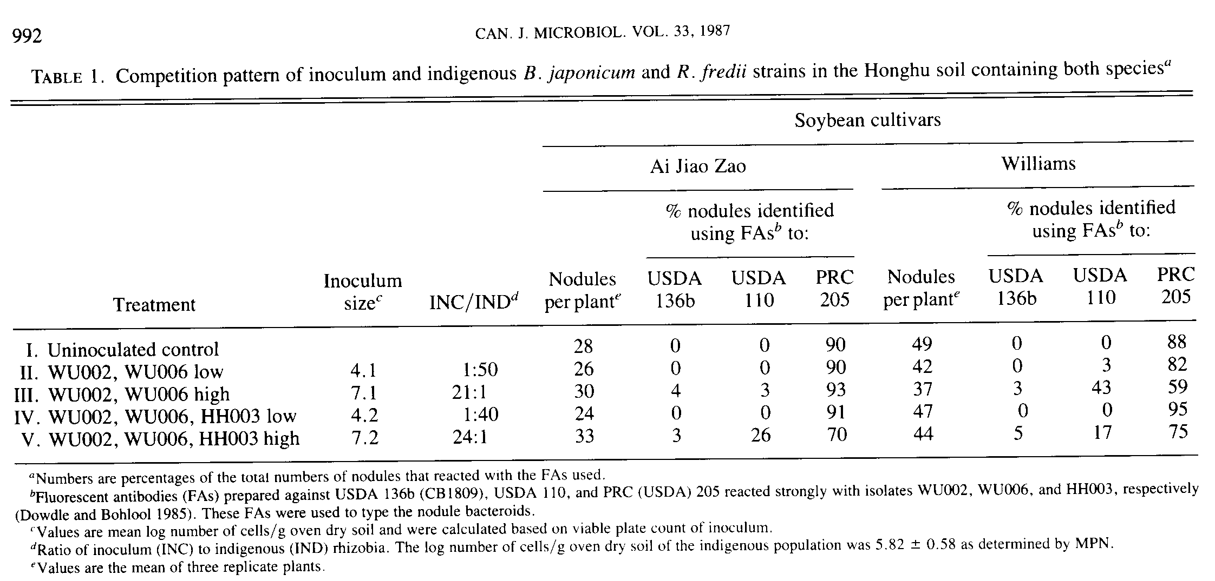
Glasshouse experiment
Inocula were added to the soils at two levels and were mixed thoroughly into the soil to simulate the distribution of indigenous rhizobia. Thorough mixing of the inoculum and the soil was accomplished by first incorporating the inoculum strains into peat and then mixing the peat-rhizobia mixture into the soil to give the desired final numbers. Seeds were surface sterilized for 20 min in 4% (w/v) calcium hypochlorite, rinsed thoroughly in sterile water, and three seeds of each cultivar were sown into 16-oz plastic cups containing 350 g soil. Inoculum was also introduced into the soil with peat-pelleted seeds which were prepared using the procedures outlined by Vincent (1970). Each seed harbored approximately 1 x 10⁵ cells of the desired rhizobial mixture as determined by viable count on YEM agar. Seedlings were subsequently thinned leaving one seedling of each cultivar per cup. After thinning, the top of the soil was covered with a 3-cm layer of fine gravel. Soils were maintained at 60% water-holding capacity throughout the experiment. A plastic straw (6 mm diam.) extending to the bottom of the cup facilitated watering with 1/4-strength Hoagland's nitrogen-free solution. There were three replicates for each treatment arranged in a randomized complete-block design. Plants were harvested at 4 weeks, and all nodules were collected and serotyped by immunofluorescence.

Immunofluorescence
Preparation of FAs and immunofluorescence staining of nodules are described elsewhere (Schmidt et al. 1968). Strain WU002 is in the same serogroup as USDA I36b (= CB 1809) and identified using FA USDA136b, whereas WU006 was identified with FA USDA110, and HH003 with FA PRC205 (Dowdle and Bohlool 1985). Smears from nodules were treated with gelatin - rhodamine isothiocyanate conjugate to suppress nonspecific staining (Bohlool and Schmidt 1968). Reflected light fluorescence microscopy was used for FA identification of nodule occupants as described previously (May and Bohlool 1983). To detect two-strain occupancy in the same nodule, transmitted light microscopy, i.e., phase contrast with an achromatic -aplanatic DIC condenser VZ, was used to visualize nonreactive cells in nodule smears.
Results
Results in Table 1 show that in the Honghu soil, with an indigenous population of R. fredii and B. japonicum (approximately 10⁵ and 10⁴/g dry soil, respectively), the majority of nodules on uninoculated control plants were formed by indigenous R. fredii that reacted with PRC 205 FA. Inoculation with low numbers of rhizobia did not alter the competition patterns significantly (Table 1, treatments 11 and IV). However, nodule occupancy on cv. Williams could be affected in favor of B. japonicum by including them in the inoculum in high number
(Table 1, III). A comparison of treatments V with III shows an increase in WU006 occupancy on cv. Ai Jiao Zao and a decrease on cv. Williams.
In the Wuhan soil with an indigenous population of 6.3 x 1O^{z}/g dry soil of only B. japonicum, the inoculum strain of R. fredii was unable to displace the indigenous B. japonicum from nodules when the ratio of inoculum : indigenous numbers was 30:1 (Table 2, II). At a higher ratio, however, a significant numbers of nodules were occupied by R. fredii (Table 2, 111). Inclusion of B. japonicum isolates in the inoculum along with the R. fredii reduced occupancy by the latter on both cultivars, whether applied directly into the soil (Table 2, IV) or pelleted in peat on the seed (Table 2, V).
In the uninoculated treatments in the Wuhan soil (Table 2, I), B. japonicum WU002 (serogroup USDA136b) formed only a few nodules on cv. Ai Jiao Zao, but the majority of them on cv. Williams. The only treatment that increased nodule occupancy by WU002 on cv. Ai Jiao Zao was when it was included in a mixture and pelleted on the seed (Table 2, V).
In the Waimea soil, devoid of soybean rhizobia, strain WU006 was the most competitive strain occupying approximately 80% of the nodules on both cultivars; strain HH003 occupied the remaining 20% of the nodules on cv. Ai Jiao Zao, while the remaining 20% on cv. Williams were occupied by WU002 (Table 3).

Discussion

China is believed to be the center of origin and diversity of soybean (Hymowitz and Newell 1981), and presumably of its microsymbiont, Rhizobium. Until recently, soybean cultivars used in commercial production in North America were derived from relatively a narrow genetic base (Committee on Genetic Vulnerability of Major Crops, Publications Department, U.S. National Academy of Sciences, Washington, DC). Symbiotic association of these soybean lines were also believed to be exclusively with the slow-growing group of rhizobia, now designated as Bradyrhizobium japonicum. However, Keyser et al. (1982) have described an entirely different group of rhizobia, isolated from nodules of soybeans obtained from three expeditions to China. This group is now placed in a distinct species, R. fredii, on the basis of biochemical and genetic evidence.
The R. fredii isolates of Keyser et al. (1982), with a few
exceptions (Hattorie and Johnson 1984; Van Rensburg et al. 1983; Yelton et al. 1983), form ineffective nodules with most North American cultivars. The same isolates, however, are highly effective with "Peking" soybean, a genetically unimproved black-seeded variety from China, and with a number of G. soja lines (Keyser and Cregan 1984). In a more recent collection of R. fredii from an uninoculated soybean field in China, Dowdle and Bohlool (1985) have found a number of isolates that were equally, or more, effective than the B. japonicum strain USDA I10 on two North American cultivars, Davis and Williams.
McLoughlin et al. (1984) have shown that the pattern of competition between fast- and slow-growing R. japonicum on soybeans grown in pouches an in soils containing slow-growing rhizobia varied with strains, soybean cultivar and soils. Similarily, in our study, competition between the fast- and slowgrowing strains was influenced by cultivar, method of inoculation, and more dramatically by the indigenous rhizobia.
Intra- and inter-specific competition in R. fredii and B. japonicum as indigenous and introduced organisms was studied on two soybean cultivars grown in three soils. Two of the soils were from China (Dowdle and Bohlool 1985), one from a soybean field in Honghu with no history of Rhizobium inoculation but containing both R. fredii and B. japonicum; and another from a rice field in Wuhan with no history of soybean
cultivation, and containing only B. japonicum population. A third soil from Hawaii was devoid of either species. Nodule occupancy data of the uninoculated control plants in the Honghu soil (Table 1) confirm our previous results (Dowdle and Bohlool 1985) that the majority of nodules on both cultivars were formed by R. fredii which reacted with PRC205 FA. None of the nodules reacted with FAs against B. japonicum strains. This was despite the fact that B. japonicum were present in this soil in high numbers as evidenced by their recovery at the higher dilution (10⁻²-10⁻⁴) of rhizosphere soil (Dowdle and Bohlool 1985). In the Wuhan soil (Table 2) uninoculated plants harbored nodules occupied by B. japonicum, the majority of which could be identified using USDA110 or USDA136b FAs.
Inoculation with B. japonicum and R. fredii did not result in significant increases in nodule numbers on either cultivar in either soil (Table 1 and 2). Nodules occupancy by the inoculum strain could be achieved in both soils, but only at high ratios of inoculum to indigenous rhizobia (Table 1, 111 and V; Table 2, 111). In the Honghu soil with an indigenous population of 6.6 x 10⁵ total rhizobia/g dry soil, nodule occupancy by indigenous R. fredii could be reduced from 88% (Table 1, I) to 50 and 75% when high rates of B. japonicum or B. japonicum and R. fredii, respectively, were inoculated into the soil (Table 1,111 and IV). Likewise, in Wuhan soil with an indigenous population of 6.3 x 10² total B. japonicumlg dry soil, introduced R. fredii could
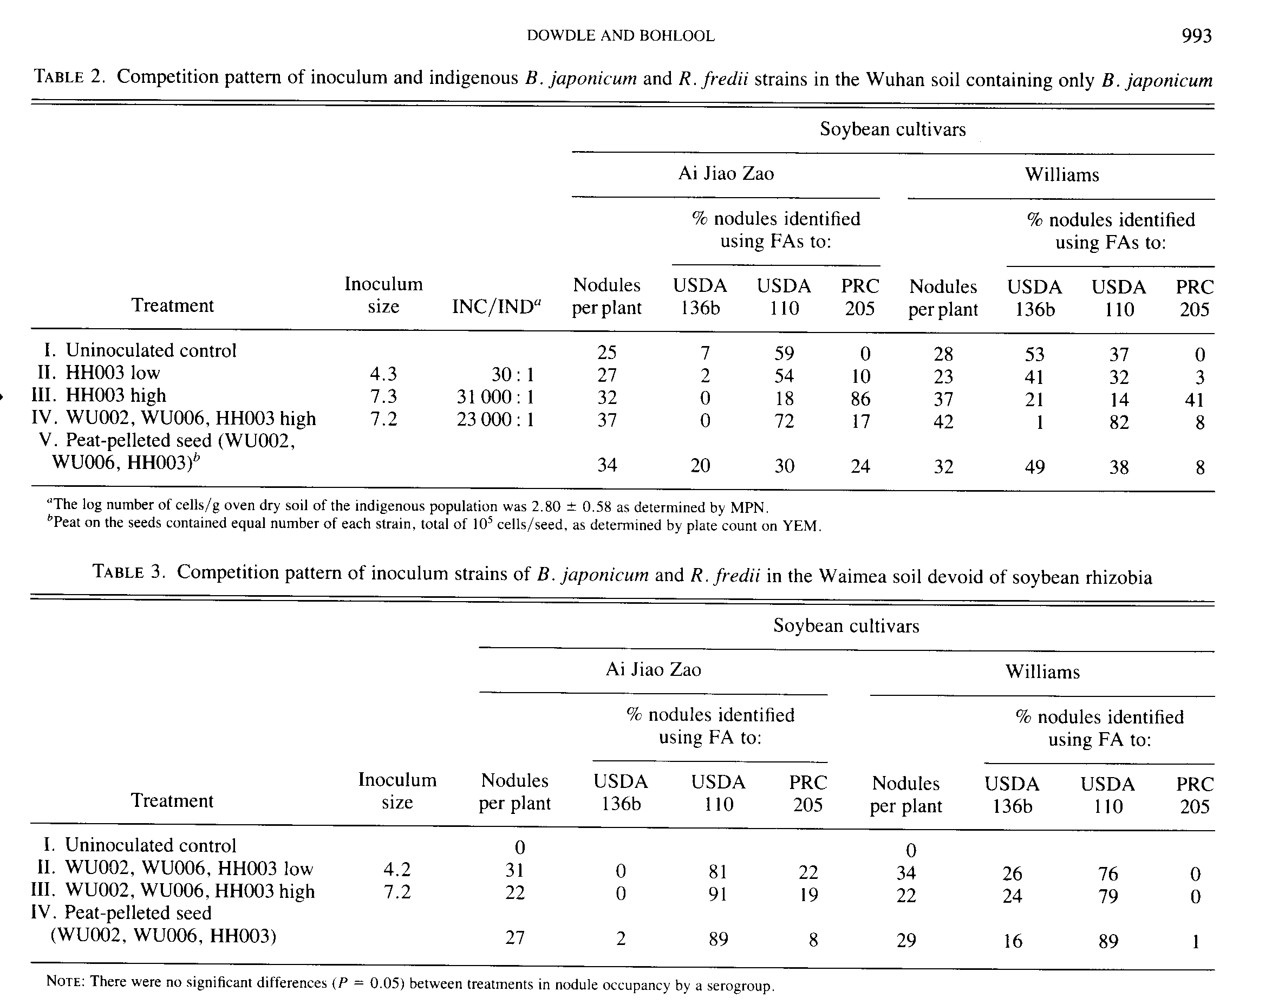
CAN. J. MICROBIOL. VOL. 33, 1987
occupy a significant number of nodules (Table 2, III), but only when B. japonicum was not included in the inoculum (Table 2, IV). Pelleting of the seed with two isolates of B. japonicum and one of R. fredii favored the former (Table 2, V).
Trinick et al. (1983) studied competition between a fast grower and a slow grower and reported that when the total numbers in a mixed inoculum were low, the fast-growing strain was a better competitor. On the other hand, when the numbers in the inoculum were high, the slow-growing strain was the better strain and formed more nodules. Our results show that in a soil devoid of soybean rhizobia, the total number of cells in the inoculum had no influence on the competition pattern of the inoculum strains (Table 3).
Based on data from Weaver and Frederick (1974), it can be predicted that in soils in the soybean-growing region of midwestern United States, if the inoculum rhizobia are to form 50% or more of the nodules, then an inoculation rate of at least 1000 times the soil rhizobial population must be used. Our studies also illustrated that high ratios of inoculum : indigenous numbers were required to displace indigenous rhizobia from nodules. For example, in the Wuhan rice soil inoculum R. fredii occupied 86% of the nodules on cv. Ai Jiao Zao and 41 % of the nodules on cv. Williams, but only when its ratio in the inoculum to indigenous rhizobia 31000: 1. When HH003 was mixed into the soil in lower numbers, or mixed into the soil together with two cultured indigenous B. japonicum isolates, its nodule occupancy was significantly lower.
In most of the treatments, HH003 was more competitive on cv. Ai Jiao Zao than on cv. Williams (Tables 1-3). This is consistent with the observation that cv. Williams had a greater affinity for B. japonicum, whereas cv. Ai Jiao Zao had a greater affinity for R. fredii, based on the nitrogen’fixing effectiveness of the symbioses formed between the two cultivars and the various isolates from the soybean and rice soil (Dowdle and Bohlool 1985).
Competition between the slow-growing B. japonicum isolates was also influenced by the soybean cultivars. This was due, in large part, to the ineffective symbiotic association between cv. Ai Jiao Zao and WU002 (Dowdle and Bohlool 1985). Diatloff and Brockwell (1976) observed a similar pattern of poor competitiveness with an ineffective cultivar (Hardee) - strain CB 1809 association and high competitiveness with an effective cultivar. (Hampton) - strain CB 1809 association. Furthermore, they reported that when an ineffective strain was included in the inoculum, nodule formation by the effective strains was suppressed. This suppression effect did not occur in our study.
Although the number of rhizobia differed greatly between inoculum treatments, there was no significant effect on the number of nodules formed. Between 0 and 5% of the nodules were doubly infected by either two slow growers or by fast and slow growers. Dual occupancy of nodules by fast- and slowgrowing rhizobia has been reported before (Trinick et al. 1983).
The results of this study demonstrate that, at least in one soil, the R. fredii are highly competitive when they are native. More studies in soils from China are needed to determine the extent of the occurence of fast-growing soybean rhizobia, their competitiveness under natural conditions, and their symbiotic effectiveness on genetically diverse cultivars of soybeans.

Acknowledgements
This work was supported in part by contract AID/ta-c-1207 (NifrAL Project), USDA (406 grant no. 58-9AHZ-2-670) and
by a fellowship (to S.F. D.) from the U.S. National Academy of Science's Committee on Scholarly Communications with the People's Republic of China.
BOHLOOL, B. B., and SCHMIDT, E. L. 1968. Nonspecific staining: its control in immunofluorescence examination of soil. Science (Washington, D.C.), 162: 1012-1014.
1973. Persistence and competition aspects of Rhizobium japonicum observed in soil by immunofluorescence microscopy. Soil. Sci. Soc. Am. J. 73: 561-564.
BOONKERD, N., WEBER, D. F., and BEZDICEK, D. F. 1978. Influence of Rhizobium japonicum strains and inoculation methods on soybean grown in rhizobia-populated soils. Agron. J. 70: 547-549.
DAMIRGI, S. M., FREDERICK, L. R. and ANDERSON, 1. C. 1967. Serogroups of Rhizobium japonicum in soybean nodules as affected by soil types. Agron. J. 59: 10-12.
DIATLOFF, A., and BROCKWELL, J. 1976. Symbiotic properties of Rhizobium japonicum and competitive sources success in nodulation of two Glycine max cultivars by effective and ineffective strains. Aust. J. Exp. Agric. Anim. Husb. 16: 514-521.
DoWDLE, S. F., and BOHLOOL, B. B. 1985. Predominance of fast-growing Rhizobium japonicum in a soybean field in the People's Republic of China. Appl. Environ. Microbiol. 50: 1171-1176. FRANCO, A. A., and VINCENT, J. M. 1976. Competition amongst rhizobial strains for the colonization and nodulation of two tropical legumes. Plant Soil, 45: 27-48.
HAM, G. E. 1980. Inoculation of legumes with Rhizobium in conpetition with naturalized strains. pp. 131-138. In Nitrogen fixation. Vol. 2. Edited by W. E. Newton and W. H. Orme-Johnson. University Park Press, Baltimore.
HAM, G. E., CALDWELL, V. B. and JOHNSON, H. W. 1971x. Evaluation of Rhizobium japonicum inoculants in soils containing naturalized populations of rhizobia. Agron. J. 63: 301-303.
HAM, G. E., FREDERICK, L. R., and ANDERSON, 1. C. 1971 b. Serogroups of Rhizobium japonicum in soybean nodules sampled in Iowa, Agron. J. 63: 69-72.
HATTORI, J., and JOHNSON, D. A. 1984. Fast-growing Rhizobium japonicum that effectively nodulates several commercial Glycine max L. Merril cultivars. Appl. Environ. Microbiol. 48: 234-235. HOAGLAND, D. R., and ARNON, D. I. 1938. The water culture method for growing plants without soil. Calif. Agric. Exp. Stn. Circ. 347. HYMOWITZ, T., and NEWELL, C. A. 1981. Taxonomy of the genus Glycine, domestication, and uses of soybeans. Econ. Bot. 35: 272-288.
JOHNSON, H. W., MEANS, U. M., and WEBER, C. R. 1965. Competion for nodule sites between strains of Rhizobium japonicum applied as inoculum and strains in the soil. Agron. J. 57: 179-185.
KAPUSTA, G., and ROUWENHORST, D. L. 1973. Influence of inoculum size on Rhizobium japonicum serogroup distribution frequency in soybean nodules. Agron. J. 65: 916-919.
KEYSER, H. H., and CREGAN, P. B. 1984. Interactions of selected Glycine soja Sieb. and Zucc. genotypes with fast- and slow-growing soybean rhizobia. Crop. Sci. 24: 1059-1062.
KEYSER, H. H., BOHLOOL, B. B., Hu, T. S., WEBER, D. F. 1982. Fast-growing rhizobia isolated from nodules of soybean. Science (Washington, D.C.), 215: 1631-1632.
KOSSLAK, R. M., and BOHLOOL, B. B. 1985. Influence of environmental factors on interstrain competition in Rhizobium japonicum. Appl. Environ. Microbiol. 49: 1128-1133.
MAY, S. N., and BOHLOOL, B. B. 1983. Competition among Rhizobium leguminosarum strains for nodulation of lentils (Lens esculenta). Appl. Environ. Microbiol. 45: 960-965.
MCLOUGHLIN, T. J., OWENS, P. A., and ALT, S. G. 1984. Competition studies with fast-growing Rhizobium japonicum strains. Can. J. Microbiol. 31: 220-223.
MOAWAD, H. A., ELLIS, W. R., and SCHMIDT, E. L. 1984. Rhizosphere response as a factor in competition among three serogroups of indigenous Rhizobium japonicum for nodulation of field-grown soybeans. Appl. Environ. Microbiol. 47: 607-612.
5
DOWDLE AND BOHLOOL
6
SADOWSKY, M. J., KEYSER, H. H., and BOHLOOL, B. B. 1983. Biochemical characterization of fast- and slow-growing rhizobia that nodulate soybeans. Int. J. Syst. Bacteriol. 33: 716-722.
SADOWSKY, M. J., BOHLOOL, B. B., and KEYSER, H. H. 1987. Serological relatedness of Rhizobium fredii to other rhizobia and to the bradyrhizobia. Appl. Environ. Microbiol. 41: 679-685.
SCHMIDT, E. L., BANKOLE, R. O., and BOHLOOL, B. B. 1968. Fluorescent antibody approach to the study of rhizobia in soil. J. Bacteriol. 95: 1987-1992.
SCHMIDT, E. L., ZIDWICK, M. J., and ABEBE, H. M. 1986. Bradyrhizobium japonicum serocluster 123 and diversity among member isolates. Appl. Environ. Microbiol, 51: 1212-1215. SCHOLLA, M. H., and ELKAN, G. H. 1984. Rhizobium fredii sp. nov., a fast-growing species that effectively nodulates soybeans. Int. J. Syst. Bacteriol. 34: 484-486.
SOMASEGARAN, P., and HOBEN, H. 1985. Methods in legume-Rhizobium/Technology. NifrAL Publication, Library of Congress ISBN 87-106109.
STOWERS, M. D., and EAGLESHAM, A. R. J. 1984. Physiological and symbiotic characteristics of fast-growing Rhizobium japonicum. Plant Soil, 77: 3-14.
TRINICK, M. J., RHODES, R. L., and GALBRAITH, J. H. 1983. Competition between fast- and slow-growing tropical legume rhizobia for nodulation of Vigna unguiculata. Plant Soil, 73: 105-115.
VAN RENSBURG, H. J., STUDOM, B. W., and, OTTO, C. J. 1983. Effective nodulation of soybeans by fast-growing strains of Rhizobium japonicum. S. Afr. J. Sci. 79: 251-252.
VINCENT, J. M. 1970. A manual for the practical study of root-nodule bacteria. IBP Handbook no. 15. Blackwell Scientific Publications, Oxford.
WEAVER, R. W., and FREDERICK, L. R. 1974. Effect of inoculum rate on competitive nodulation of Glycine max L. Merrill. 11. Field studies. Agron. J. 66: 233-236.
YELTON, M. M., YANG, S. S., EDIE, S. A., and LIM, S. T. 1983. Characterization of an effective salt-tolerant, fast-growing strain of Rhizobium japonicum. J. Gen. Microbiol. 129: 1537-1547. ZABLOTOWITZ, R. M., and FOCHT, D. D. 1981. Physiological characteristics of cowpea rhizobia: evaluation of symbiotic efficiency in Vigna unguiculata. Appl. Environ. Microbiol. 41: 679-685.

